Task No & Title: | BSBCMN211A Participate in workplace safety procedures
Title: | Ergonomics Explained worksheet
Suitable for Classes: | Certificate II Business Cert II in ICT, AIT 1
Area: | Technology & Enterprise
Teacher: | Mr Peter Faulks
Timeline | 1 Lesson
Date Due: | Today

Task Brief:
Files Required | Camera

Items highlighted in yellow are tasks for you to complete
Items in Blue are help tips

ERG100 Ergonomics Office Design Worksheet

Choose from two (2) options

1. OUR CLASSROOM
Provide an ergonomic analysis of your school’s computer laboratory (including a neat diagram) and provide a list of items that you consider:

(a) require changing (with suggestions)
(b) are well designed/placed ergonomically

At lease four elements MUST be discussed

Using a camera take photographic examples of your answers.

Or

2. Memo to All staff
Due to an increase in customers we are in the fortunate position of being able to put on an additional staff member in the near future. Although our working conditions are suitable on a temporary basis, we will soon need to rearrange the office to meet good ergonomic practices.

Below is a floor plan of our office as it currently is. I would like all staff members to take the opportunity to re-design the office so that it better meets ergonomic best practice.

With your design, please include a brief justification of how your rearrangement of the office furniture meets Occupational Health and Safety guidelines.
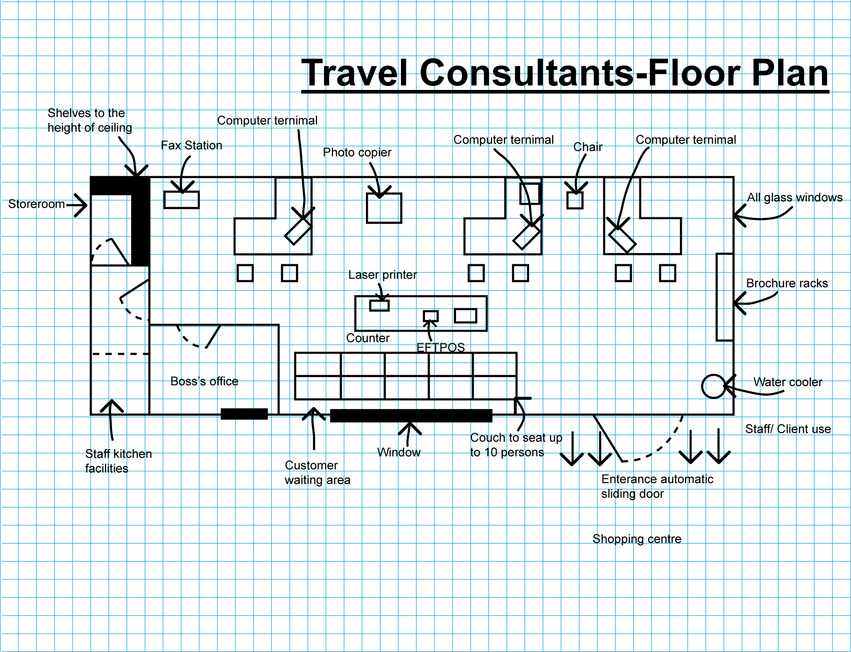

I will review all plans at that point.

Your design here please

Save the work

Student Name: | Date submitted:
I declare this evidence to have been produced by me the undersigned.

Candidate’s signature:
Title of Portfolio evidence presented (include Unit No and section i.e. 03.05)
:-
□ Outcomes from learning programs (including self-learning and online learning)
□ Assessment feedback (from a trainer or assessor)
□ Observation checklists (from a workplace supervisor or assessor)
□ Written statements or references (including workplace supervisors, community leaders)
□ Job descriptions
□ Work journal
□ Work samples
□ Finished products
□ Product descriptions or specifications (supporting the product samples included)
□ Statutory declarations
□ List others (or delete any from above not provided)
- All work submitted to be word processed and spell checked.
- There must be at least two samples of evidence for each
Element within the Unit of Competency. This is sample 1 / 2
- All work submitted must be of a high quality and meet the
requirements of the Unit of Competency.
Other evidence (List each piece):
Assessor to complete
Evidence is Valid Sufficient Authentic Current
□ □ □ □

Assessor signature: _________________________________Date: _____________
Peter Faulks, BA Soc Sci, Grad Dip Ed, Cert IV AWT
Certificate II in Business assessor/teacher
Assessor to complete

Student is declared Competent Not Yet Competent
□ □

Keep a copy of this report with your file for evidence

